**Task 1:** **Simple Calculator Application**

- Objective: Create a basic calculator application in Java.

- Functionality: Your program should be capable of performing addition, subtraction, multiplication, and division operations.

- Details: Your task is to design a user-friendly interface that allows users to input two numbers and choose the operation they want to perform. The program should then display the result of the operation.

**Algorithm:**

1. **add(Component c)** : adds component to container.
2. **addActionListenerListener(ActionListener d)**: add actionListener for specified component
3. **setBackground(Color c)** : sets the background color of the specified container
4. **setSize(int a, int b)**: sets the size of container to specified dimensions.
5. **setText(String s)**: sets the text of the label to s.
6. **getText()** : returns the text of the label.

**CODE**

import javax.swing.*;

import java.awt.event.*;

class Calc implements ActionListener

{

JFrame f;

JTextField t;

JButton b1,b2,b3,b4,b5,b6,b7,b8,b9,b0,bdiv,bmul,bsub,badd,bdec,beq,bdel,bclr;

static double a=0,b=0,result=0;

static int operator=0;

Calc()

{

f=new JFrame("Calculator");

t=new JTextField();

b1=new JButton("1");

b2=new JButton("2");

b3=new JButton("3");

b4=new JButton("4");

b5=new JButton("5");

b6=new JButton("6");

b7=new JButton("7");

b8=new JButton("8");

b9=new JButton("9");

b0=new JButton("0");

bdiv=new JButton("/");

bmul=new JButton("*");

bsub=new JButton("-");

badd=new JButton("+");

bdec=new JButton(".");

beq=new JButton("=");

bdel=new JButton("Delete");

bclr=new JButton("Clear");

t.setBounds(30,40,280,30);

b7.setBounds(40,100,50,40);

b8.setBounds(110,100,50,40);

b9.setBounds(180,100,50,40);

bdiv.setBounds(250,100,50,40);

b4.setBounds(40,170,50,40);

b5.setBounds(110,170,50,40);

b6.setBounds(180,170,50,40);

bmul.setBounds(250,170,50,40);

b1.setBounds(40,240,50,40);

b2.setBounds(110,240,50,40);

b3.setBounds(180,240,50,40);

bsub.setBounds(250,240,50,40);

bdec.setBounds(40,310,50,40);

b0.setBounds(110,310,50,40);

beq.setBounds(180,310,50,40);

badd.setBounds(250,310,50,40);

bdel.setBounds(60,380,100,40);

bclr.setBounds(180,380,100,40);

f.add(t);

f.add(b7);

f.add(b8);

f.add(b9);

f.add(bdiv);

f.add(b4);

f.add(b5);

f.add(b6);

f.add(bmul);

f.add(b1);

f.add(b2);

f.add(b3);

f.add(bsub);

f.add(bdec);

f.add(b0);

f.add(beq);

f.add(badd);

f.add(bdel);

f.add(bclr);

f.setLayout(null);

f.setVisible(true);

f.setSize(350,500);

f.setDefaultCloseOperation(JFrame.EXIT_ON_CLOSE);

f.setResizable(false);

b1.addActionListener(this);

b2.addActionListener(this);

b3.addActionListener(this);

b4.addActionListener(this);

b5.addActionListener(this);

b6.addActionListener(this);

b7.addActionListener(this);

b8.addActionListener(this);

b9.addActionListener(this);

b0.addActionListener(this);

badd.addActionListener(this);

bdiv.addActionListener(this);

bmul.addActionListener(this);

bsub.addActionListener(this);

bdec.addActionListener(this);

beq.addActionListener(this);

bdel.addActionListener(this);

bclr.addActionListener(this);

}

public void actionPerformed(ActionEvent e)

{

if(e.getSource()==b1)

t.setText(t.getText().concat("1"));

if(e.getSource()==b2)

t.setText(t.getText().concat("2"));

if(e.getSource()==b3)

t.setText(t.getText().concat("3"));

if(e.getSource()==b4)

t.setText(t.getText().concat("4"));

if(e.getSource()==b5)

t.setText(t.getText().concat("5"));

if(e.getSource()==b6)

t.setText(t.getText().concat("6"));

if(e.getSource()==b7)

t.setText(t.getText().concat("7"));

if(e.getSource()==b8)

t.setText(t.getText().concat("8"));

if(e.getSource()==b9)

t.setText(t.getText().concat("9"));

if(e.getSource()==b0)

t.setText(t.getText().concat("0"));

if(e.getSource()==bdec)

t.setText(t.getText().concat("."));

if(e.getSource()==badd)

{

a=Double.parseDouble(t.getText());

operator=1;

t.setText("");

}

if(e.getSource()==bsub)

{

a=Double.parseDouble(t.getText());

operator=2;

t.setText("");

}

if(e.getSource()==bmul)

{

a=Double.parseDouble(t.getText());

operator=3;

t.setText("");

}

if(e.getSource()==bdiv)

{

a=Double.parseDouble(t.getText());

operator=4;

t.setText("");

}

if(e.getSource()==beq)

{

b=Double.parseDouble(t.getText());

switch(operator)

{

case 1: result=a+b;

break;

case 2: result=a-b;

break;

case 3: result=a*b;

break;

case 4: result=a/b;

break;

default: result=0;

}

t.setText(""+result);

}

if(e.getSource()==bclr)

t.setText("");

if(e.getSource()==bdel)

{

String s=t.getText();

t.setText("");

for(int i=0;i<s.length()-1;i++)

t.setText(t.getText()+s.charAt(i));

}

}

public static void main(String...s)

{

new Calc();

}

}

**OUTPUT:** 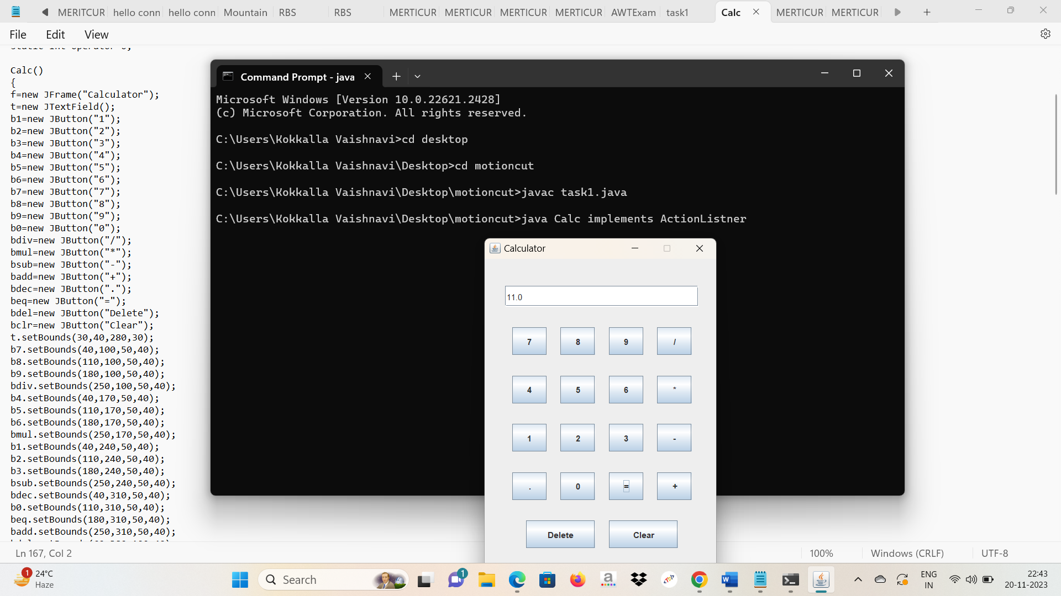

**Task 2: Number Guessing Game**

- Objective: Develop a simple number guessing game in Java.

- Functionality: The computer generates a random number, and the user's objective is to guess it.

- Details: Your game should generate a random number within a specified range (e.g., 1 to 100). Users will input their guesses, and your program should provide feedback on whether the guess is too high, too low, or correct. Additionally, keep track of the number of attempts the user makes and display this count when they guess correctly.

**Algorithm**

* If the guessed number is bigger than the actual number, the program will respond with the message that the guessed number is higher than the actual number.
* If the guessed number is smaller than the actual number, the program will respond with the message that the guessed number is lower than the actual number.
* If the guessed number is equal to the actual number or if the **K** trials are exhausted, the program will end with a suitable message.

**Approach**

* The approach is to generate a random number using Math.random() method in Java.
* Now using a loop, take **K** input from the user and for each input print whether the number is smaller or larger than the actual number.
* If within **K** trials the user guessed the number correctly, print that the user won.
* Else print that he was not able to guess and then print the actual number.

**CODE:**

// Java program for the above approach

import java.util.Scanner;

public class task2 {

// Function that implements the

// number guessing game

public static void

guessingNumberGame()

{

// Scanner Class

Scanner sc = new Scanner(System.in);

// Generate the numbers

int number = 1 + (int)(100

* Math.random());

// Given K trials

int K = 5;

int i, guess;

System.out.println(

"A number is chosen"

+ " between 1 to 100."

+ "Guess the number"

+ " within 5 trials.");

// Iterate over K Trials

for (i = 0; i < K; i++) {

System.out.println(

"Guess the number:");

// Take input for guessing

guess = sc.nextInt();

// If the number is guessed

if (number == guess) {

System.out.println(

"Congratulations!"

+ " You guessed the number.");

break;

}

else if (number > guess

&& i != K - 1) {

System.out.println(

"The number is "

+ "greater than " + guess);

}

else if (number < guess

&& i != K - 1) {

System.out.println(

"The number is"

+ " less than " + guess);

}

}

if (i == K) {

System.out.println(

"You have exhausted"

+ " K trials.");

System.out.println(

"The number was " + number);

}

}

// Driver Code

public static void

main(String arg[])

{

// Function Call

guessingNumberGame();

}

}

**OUTPUT:** 